Twisted Tactics Battle System

Version <1.0>
Submit Date<30 NOV 2010>
Revision History
Date | Version | Description | Author
<30 NOV 2010> | <1.0> | Feature Portfolio | Cris Kamurai

Table of Contents
Page

1. Introduction 4

1.1 Purpose 4

1.2 Scope 4

1.4 References 4

2. Title Selection 4

3. Title Menu Selection 5

4. Help / Information Screens 7

5. In-Game Navigation 8

6. Main Menu Section 11

7. In-Game Menu Options 13

8. Supporting Information 14
Appendix 14
Index 15

Feature Portfolio

1. Introduction
<State what this document is and related documents.>

This document is designed to express which features will be required for the project to work effectively.

Purpose
<State the purpose of this document and what information it is supposed to provide.>

The purpose of this document is to determine which features will be necessary for the program, based on the needs of the project.

Scope
<This section should list the goals, and priorities of what is to be accomplished in this document.>

The scope of this document is to use basic language, supported by UML diagrams, to explain and determine the project’s feature, most likely per screen.

References
<This section should list references to information sources outside the creative properties of the authors>

All GDR documentation for Twisted Tactics Battle System.

2. Title Selection
<This section should contain a full listing, possibly divided into sub categories, of features that are to available to be used for each Title screen designed in the game.>

2.1 Feature List
Navigate to Title Menu Screen gotoMenu:
Load starting menu screen.

View Title displayTitle:
Display title for player to view.

2.2 Title Use Case Diagram
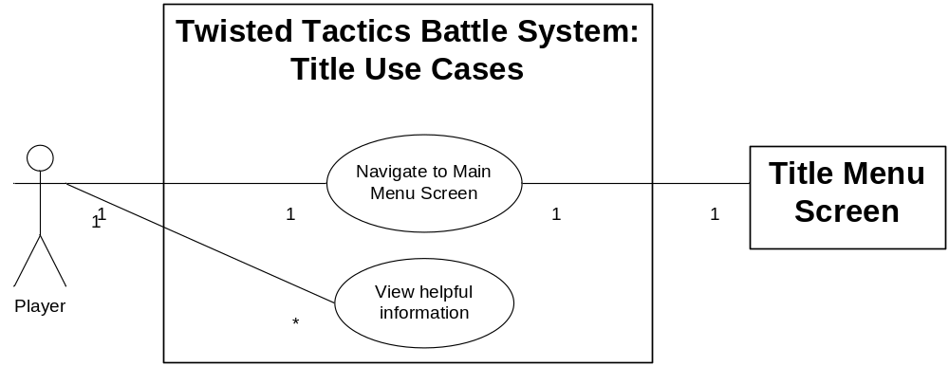

3. Title Menu Selection
<This section should contain a full listing, possibly divided into sub categories, of features that are to available to be used for each Title Menu screen designed in the game.>

3.1.1 Title Menu
Navigate to Help Screen: gotoHelp:
Load the Help / Information screen.

Navigate to Character Selection Screen: gotoCharacterSelect:
Load the Character Selection screen.

Set play mode to 1 Player: setMode1:
Define the play mode using 1 user.

Set play mode to 2 Players: setMode2:
Define the play mode using 2 users.

Set play mode to Party: loadParty:
Define the play mode to use a pre-defined party characters.

Set play mode to Stock: loadStock:
Define the play mode to use stock characters.

3.1.2 Title Menu Use Case Diagram
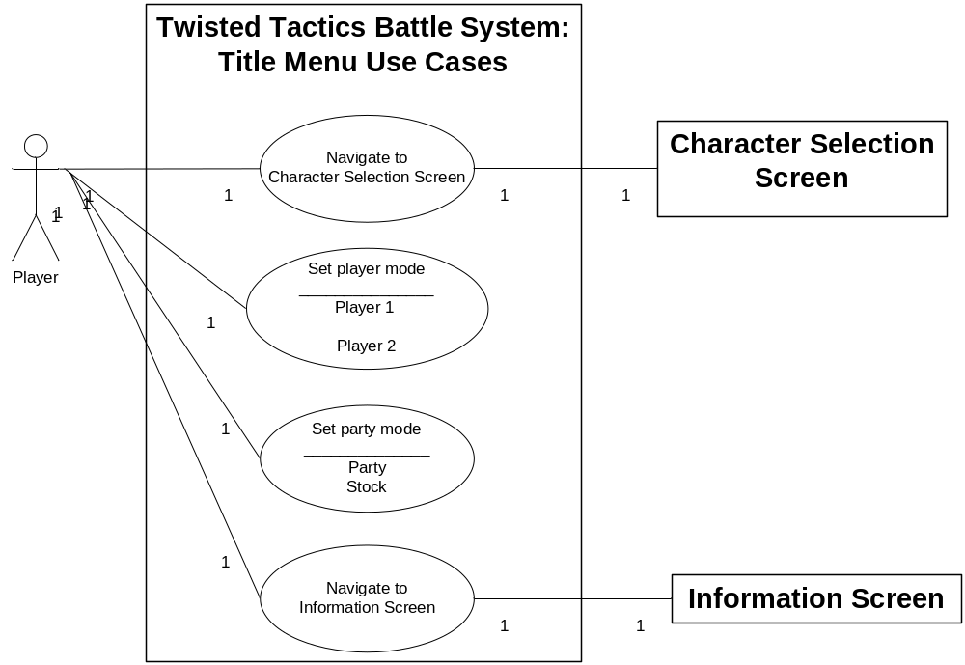

3.2.1 Character Selection
Navigate to a Playable screen gotoPlay:
Load the pre-defined screen and map

Select a Character for action selectCharacter:
The user selects a “character” from available choices

Place a Character on the board placeCharacter:
Place user controlled “character” on the tactical board.

Place Enemies on the board placeEnemies:
Place computer controlled “characters” on the tactical board.

Remove a Character from the board removeCharacter:
Remove user controlled “character” from the tactical board.

Switch to the other player’s control switchUser:
Pass turn to the next user.

View turn control viewPlayer:
Display current player.

View available “characters” viewCharacters:
Display available “characters”.

View character details. viewCharacterDetails
Display a specific character’s details.

3.2.2 Character Selection Use Case Diagram
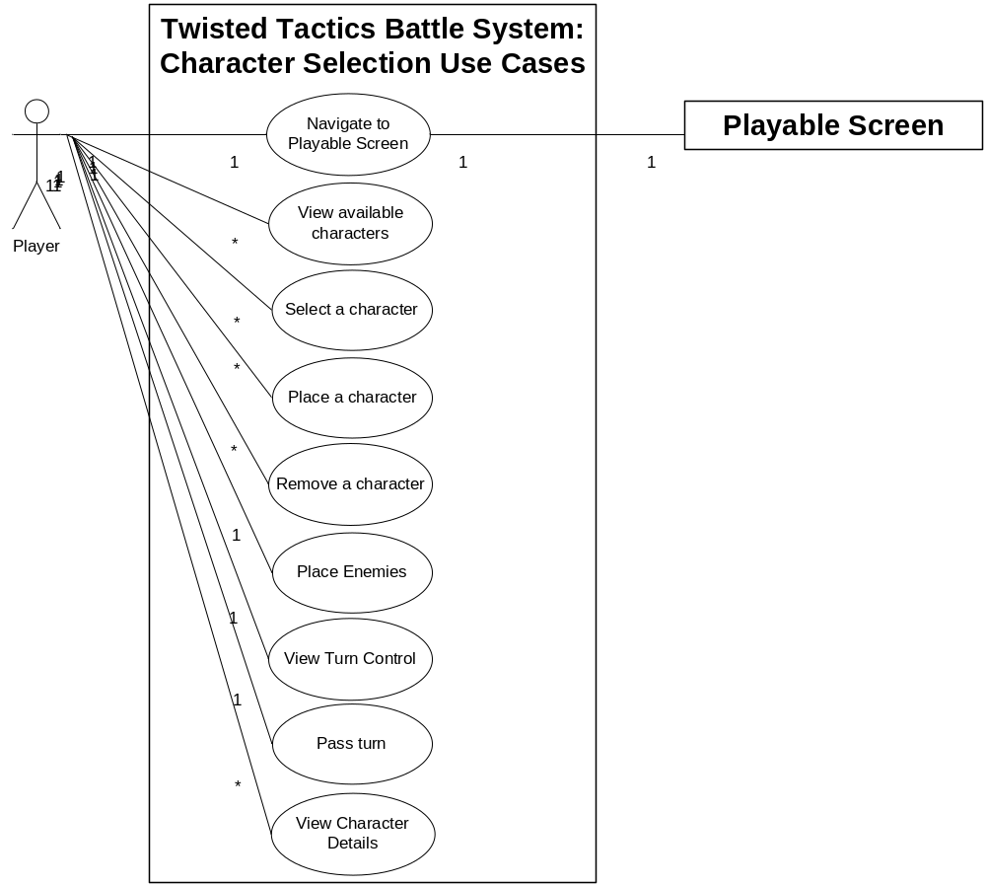

4. Help / Information Selection
<This section should contain a full listing, possibly divided into sub categories, of features that are to available to be used for each Help / Information Screen.>

4.1.1 Title Information
Read information displayInfo:
Display information for player to read.

Navigate to Title Menu returnToMenu:
Load the Title Menu Screen.
4.1.2 Title Information Use Case Diagram
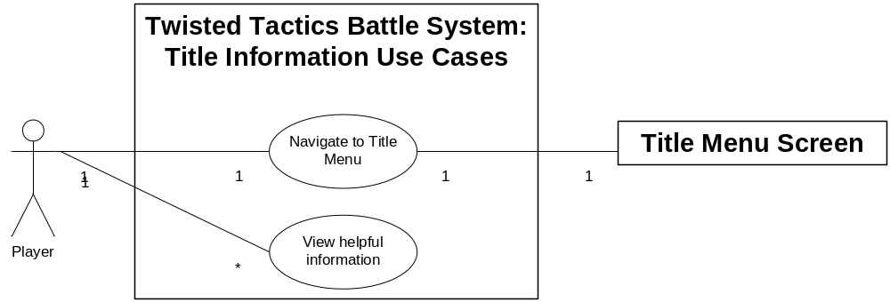

4.2.1 F1 Screen
Read information displayInfo:
Display information for player to read.

Navigate to Previous Screen returnToPrevious:
Load the Previous Screen.

4.2.2 F1 Information Use Case Diagram
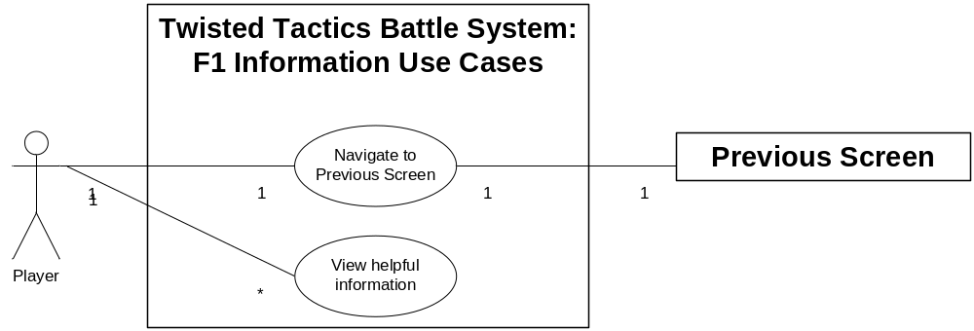

5. In-Game Navigation
<This section should contain a full listing, possibly divided into sub categories, of features that allow the user to navigate the in-game environment.>

5.1 In-Game Navigation
Arrows:

Move board cursor up moveBoardCursorUp:
Move the Cursor up on the Tactical Board.

Move board cursor left moveBoardCursorLeft:
Move the Cursor left on the Tactical Board.

Move board cursor right moveBoardCursorRight:
Move the Cursor right on the Tactical Board.

Move board cursor down moveBoardCursorDown:
Move the Cursor down on the Tactical Board.

Move menu cursor up moveMenuCursorUp:
Move the Cursor up on the menu.

Move menu cursor down moveMenuCursorDown:
Move the Cursor down on the menu.

Mouse (inclusive):

Select square selectSquare:
Select a square on the Tactical Board

Select option selectOption:
Select an option from an available menu

View:

Rotate left rotateLeft:
Rotate view of the Tactical Board 90 degrees to the left.

Rotate right rotateRight:
Rotate view of the Tactical Board 90 degrees to the right.

5.2 In-Game Navigation Use Case Diagram
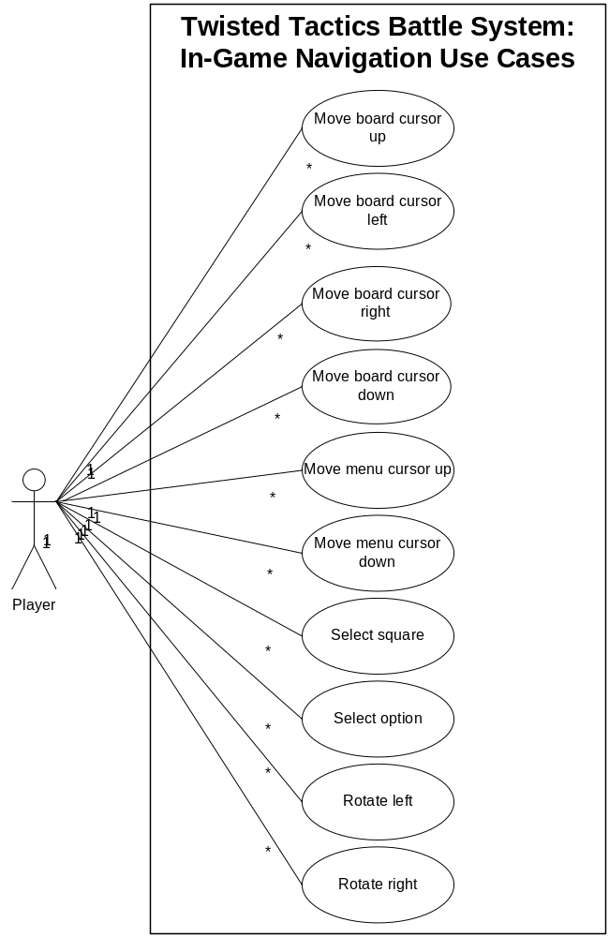

6. Main Menu Selection
<This section should contain a full listing, possibly divided into sub categories, of features that are to available to be used for each Maine Menu screen designed in the game. This includes Command Bars and HUDs (Heads Up Displays)>

6.1 Main Menu Features
View current player’s control viewPlayer:
Display current player.

Switch to the other player’s control switchUser:
Pass turn to the next user.

Select a character selectCharacter:
Select a character to perform action.

Move character assignMove:
Assign to move a character from square A to square B.

Board action boardAction
Select a special object to interact with on the Tactical Board.

Assign to attack assignAttack:
Assign a character to attack another character.

Assign to use an item assignItem:
Assign a character to use an item on a character.

Select an Item selectItem:
Select an Item for a character to use.

>Possible list of specific items<

Assign to cast spell assignMagic:
Assign a character to cast a magic spell.

Select a Spell selectSpell:
Select a Spell for a character to cast.

>Possible list of specific spells<

Assign to use technique assignTechnique:
Assign a character to use a technique.

Select a Technique selectTechnique:
Select a Technique for a character to use.

>Possible list of specific techniques<

View character statistics viewCharacter:
View statistics of a character.

Go to party menu goToPartyMenu:
Load Party Menu Screen.

Go to character menu goToCharacterMenu:
Load Character Menu Screen.

6.2 Main Menu Use Case Diagram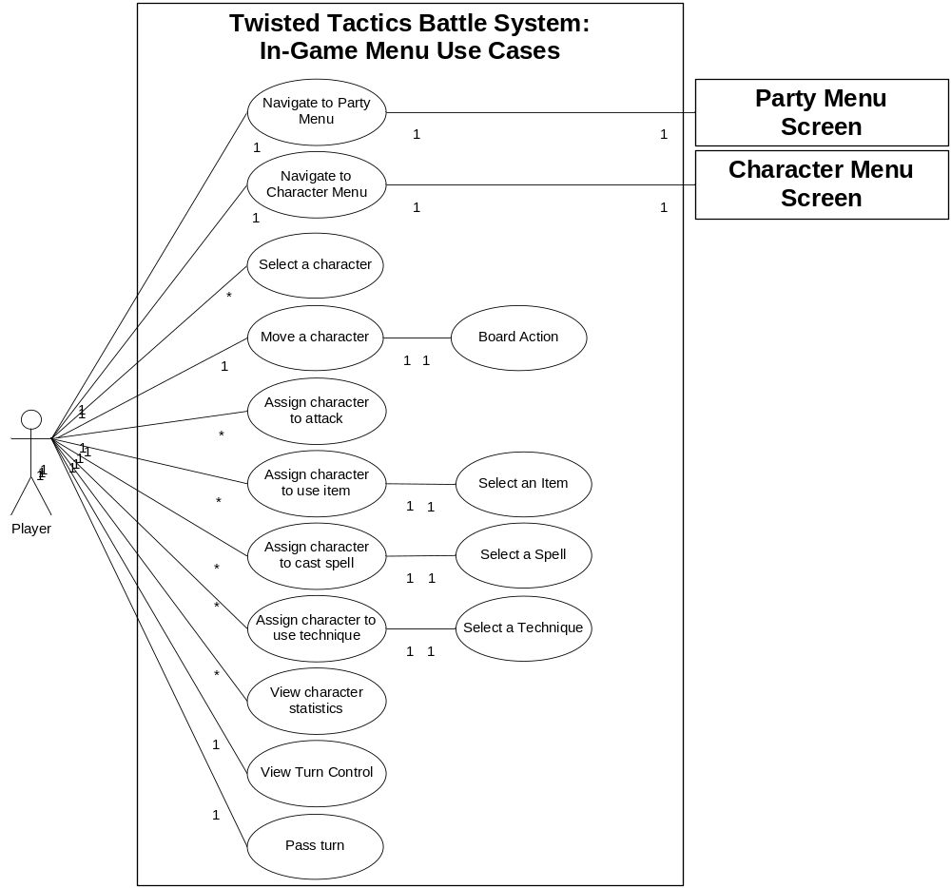

7. In-Game Options
<This section should contain a full listing, possibly divided into sub categories, of features that allow the user to take actions in the in-game environment.>

7.1 In-Game Options
Go to F1 Information Screen goToF1Information:
Load F1 Information Screen.

Reset game resetGame:
Loads Title Screen without save.

Save game saveGame:
Save current game information.

Load game loadGame:
Load current game information.

7.2 In-Game Menu and Option Use Case Diagram
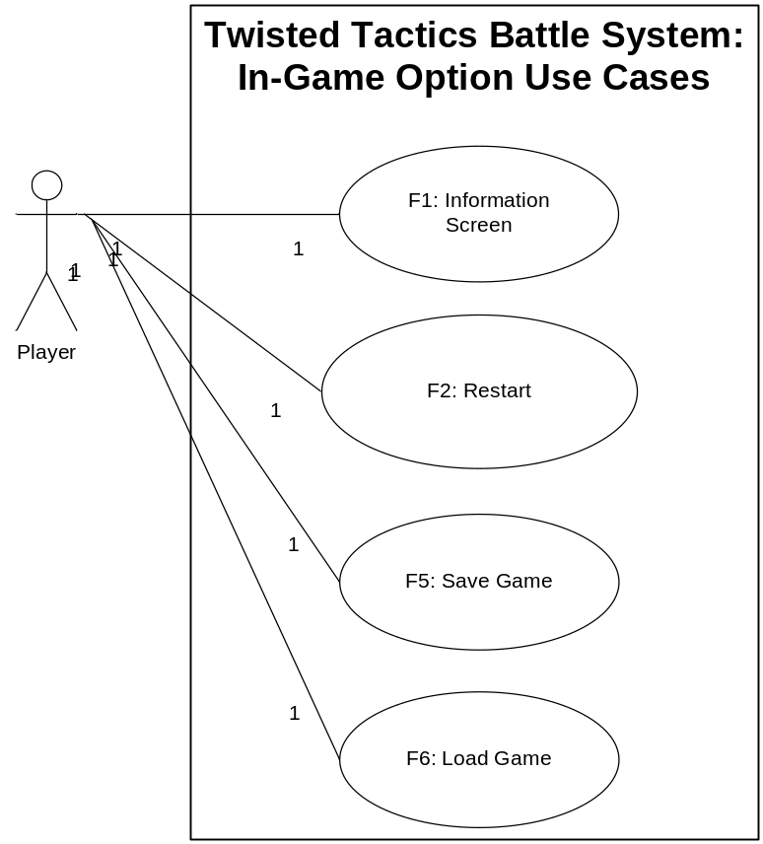

8. Supporting Information
<Any further information or locations at which further information may be obtained may be listed here.>

The inter-screen navigation is as follows, based on the previous sections’ requirements.
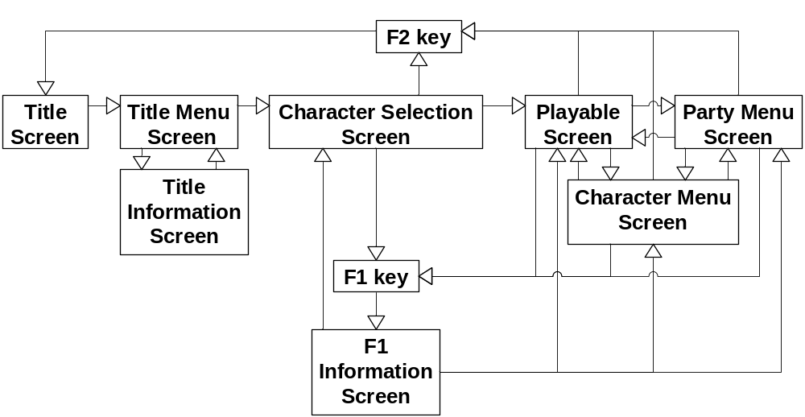

Appendix:
<Additional documentation that does not warrant an entirely separate document may be listed here.>

Index
Page
Table of Contents 3

1. Introduction 4

1.1 Purpose 4

1.2 Scope 4

1.4 References 4

2. Title Selection 4

3. Title Menu Selection 5

4. Help / Information Screens 7

5. In-Game Navigation 8

6. Main Menu Section 11

7. In-Game Menu Options 13

8. Supporting Information 14
Appendix 14

